Project Report **on**

**BuzzNews**

-dynamic news aggregator

Developers:

Vaidehi R Shreshth

Anshu V Baraiya

ABSTRACT

This project ‘BuzzNews’ is a web-based news portal built using Flask.

The project aims to develop a user-friendly news website along with gathering public participation by giving a voice to everyday readers using ‘local voices ’.

ACKNOWLEDGEMENT

I would like to express my heartfelt gratitude to all those who have supported us throughout the development of this project ‘BuzzNews’.

First and foremost, we extend our gratitude to our project guide Mr. Shaunak Purohit, who has provided us valuable insights, timely feedback and constant encouragement in shaping this project.

Finally, thank you to my peers and family for the constant motivation throughout the journey.

PROJECT PROFILE

|  |  |
| --- | --- |
| Developers | |
| NAME: | VAIDEHI R. SHRESHTH  23SI002UG03740  ANSHU V. BARAIYA  23SI002UG03572 |

|  |  |
| --- | --- |
| Project Details | |
| Project title: | Dynamic News Aggregator |
| Duration: | 3 months |
| Project name: | BuzzNews |
| Platform: | Flask (backend)  Html, CSS (frontend) |
| Team mates: | 2 |
| Guide’s name: | Mr. SHAUNAK PUROHIT |

1.SDLC OVERVIEW

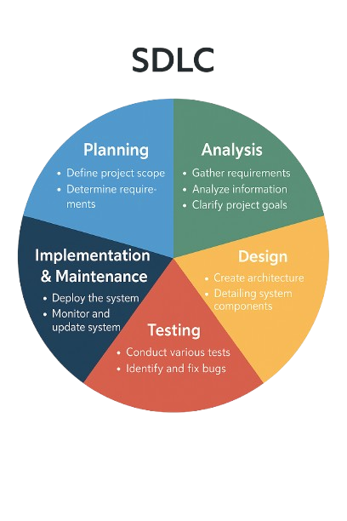

2.REQUIREMENT GATHERING

2.1 Project context :

1.name of the project :

***BuzzNews – dynamic News Aggregator***

2. nature of the project :

This project is a self-initiated academic web application developed as part of the university curriculum. It is not affiliated with any real-world organization and is designed to showcase technical skills, understanding of web technologies, and implementation of software development life cycle phases.

2.2 Idea development :

Since the idea was based on self-generated idea, no external organization meeting/ interviews were conducted.

The ideas were brainstormed and refined through personal research and taking feedbacks from peers and faculty.

1. DEVELOPER INPUT

I. Project initiators:

Vaidehi Shreshth

Anshu Baraiya

II. Vision for the project:

*“We were creating a news aggregator website at the state level coverage, but something was required to make it stand out. So, we created a website that allows readers to input a news of value to create a section for localization through which people can feel connect with their locality better.”*

* 1. Input data to the system :
* Text
* Image
  1. **Output data from the system :**
* Text
* Images
  1. **Type of project:**
* Web-Based Application
  1. **Method for requirement collection**
* Brainstorming
* Discussion with peers
* Online research on similar platforms

3. SYSTEM REQUIREMENT GATHERING

3.1 Introduction:

3.1.1 Purpose

‘BuzzNews’ is a web-based community driven news aggregator which aims in connecting the people through news – local and state level.

3.1.2 Intended audience

The intended audience of this document

is the potential end user. This document

also serves as a reference guide.

3.1.3 Product scope

The product will be an online News reading platform. The product is scaled at Gujarat level and any user can register and read news and write ‘local news’ as well.

3.2 OVERALL DESCRIPTION :

3.2.1 PRODUCT FUNCTION

I. General User Module

Register on the website

Read articles

Write on ‘local voices’

II. Journalist Module

Read articles

Create articles

III. Moderator Module

Read articles

Review/approve/reject *local voices*

Review/approve/reject journalist articles

Manage articles, categories and districts

Add/remove users

Assign roles (journalist)

IV. Admin Module

Read articles

Create articles

Review/approve/reject *local voices*

Review/approve/reject journalist articles

Manage articles, categories and districts

Add/remove users

Assign roles (moderator/journalist)

Access to admin panel

3.2.2 User classes and characteristics

1. User Classes:

General User

Journalist

Moderator

Admin

2. User Characteristics:

1. General user:

User should have basic knowledge of internet browsing to be able to navigate the website comfortably on mobile or desktop.

2.Journalist:  
 Journalist should be capable of submitting articles, uploading media files, and categorizing news properly.

3.Moderator:

Moderator must be familiar with using dashboards and handling multiple content entries.

4.Admin:

Administrator must be capable of managing the database, user accounts, and platform content.

3.2.3 operating environment

This App will be operated through the internet including hardware platforms like laptop also operating system.

3.2.4 **design and implementation constraints**

GUI is only in English.

Internet connection is necessary.

Users should have basic knowledge of internet surfing.

3.2.5 assumptions and dependencies

* Admin is already registered in the system.
* The database can be managed by the admin and partially managed by the moderator.
* Roles and tasks are predefined.

3.3 EXTERNAL INTERFACE REQUIREMENT :

3.3.1 user interface

In case the user is not registered, they can create an account by registering general information. Once the account is created, he/she can ‘login’ by entering their account credentials.

3.3.2 software interface

* Operating System
* Front end – Html, CSS, JS
* Back end – Flask, Mysql

3.4 SYSTEM FEATURES :

* To provide secure login for different user roles(user, journalist, moderator).
* Display district wise news and enables browsing for local/ state-level news.

3.5 OTHER NON-FUNCTIONAL REQUIREMENTS :

3.5.1 performance requirement:

* Overall system should be fast and error free.
* The system should be able to handle
* amount of data.

3.5.2 security requirement :

* The admin has more rights than user.
* Moderators and journalist account are created by the admin.

3.6 FEASIBILITY STUDY :

A feasibility study is a preliminary investigation of a system that checks if the system can operate smoothly for the desired purpose.

3.6.1 operational feasibility:

Operational feasibility refers to how effectively the proposed system addresses the problems and leverages the opportunities identified during the scope definition phase. It also evaluates how well the system meets the requirements outlined during the requirements analysis stage of system development.

3.6.2 technical feasibility :

Technical feasibility evaluates whether the proposed system can be developed using the existing hardware, software technologies, and available human resources.

3.6.3 economic feasibility:

Economic feasibility assesses whether the expected benefits of the system justify the costs involved in its development and implementation.  
This involves a cost-benefit analysis to determine if the project offers sufficient returns in terms of efficiency.

3.6.4 schedule feasibility:

Schedule feasibility examines whether the project can be completed within the desired time frame, considering the availability of required technical skills and resources.

4. SYSTEM ANALYSIS AND MODELING

4.1 use case diagram :

I. Admin side

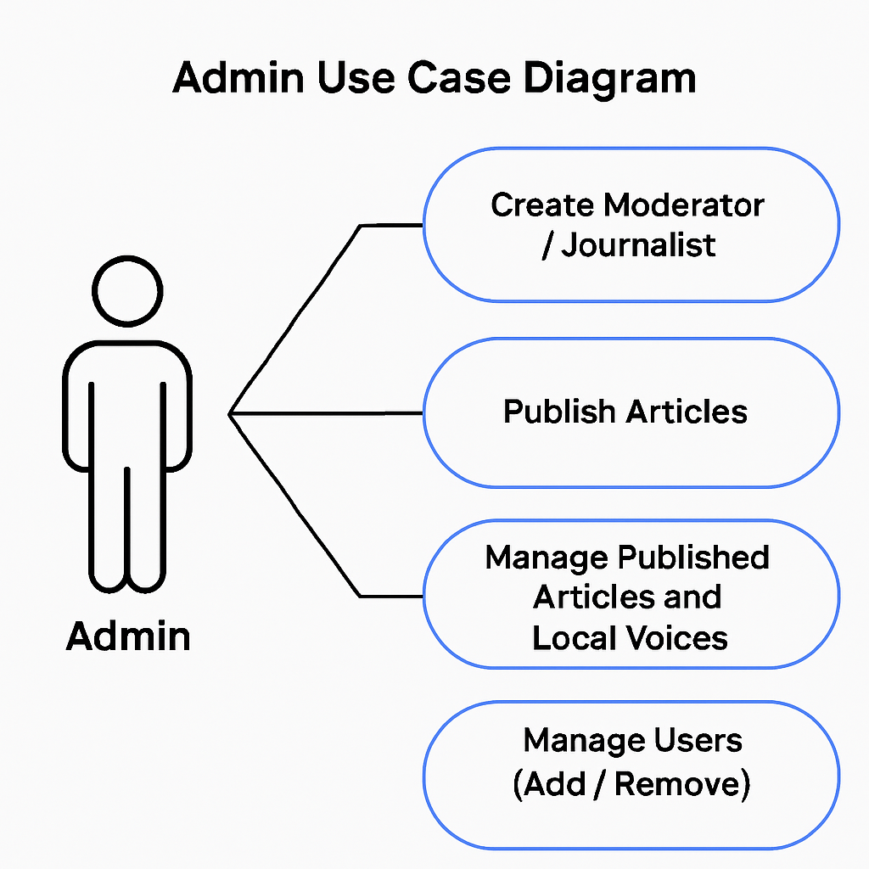

II. Moderator side

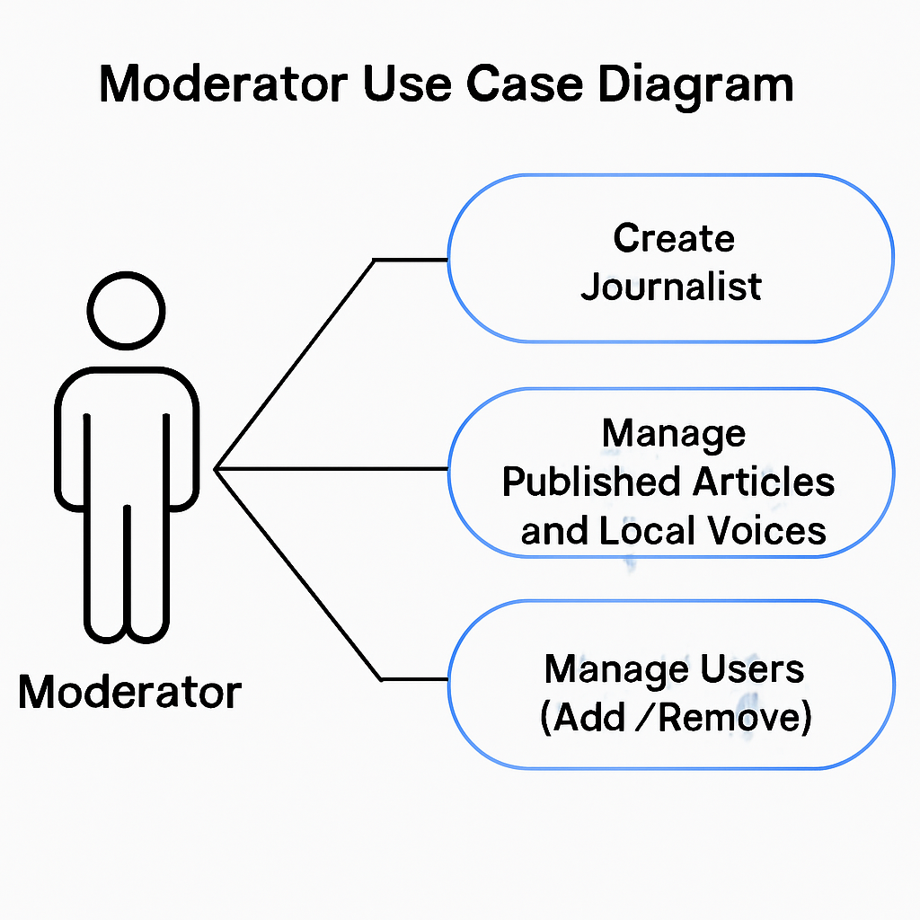

III. Journalist side 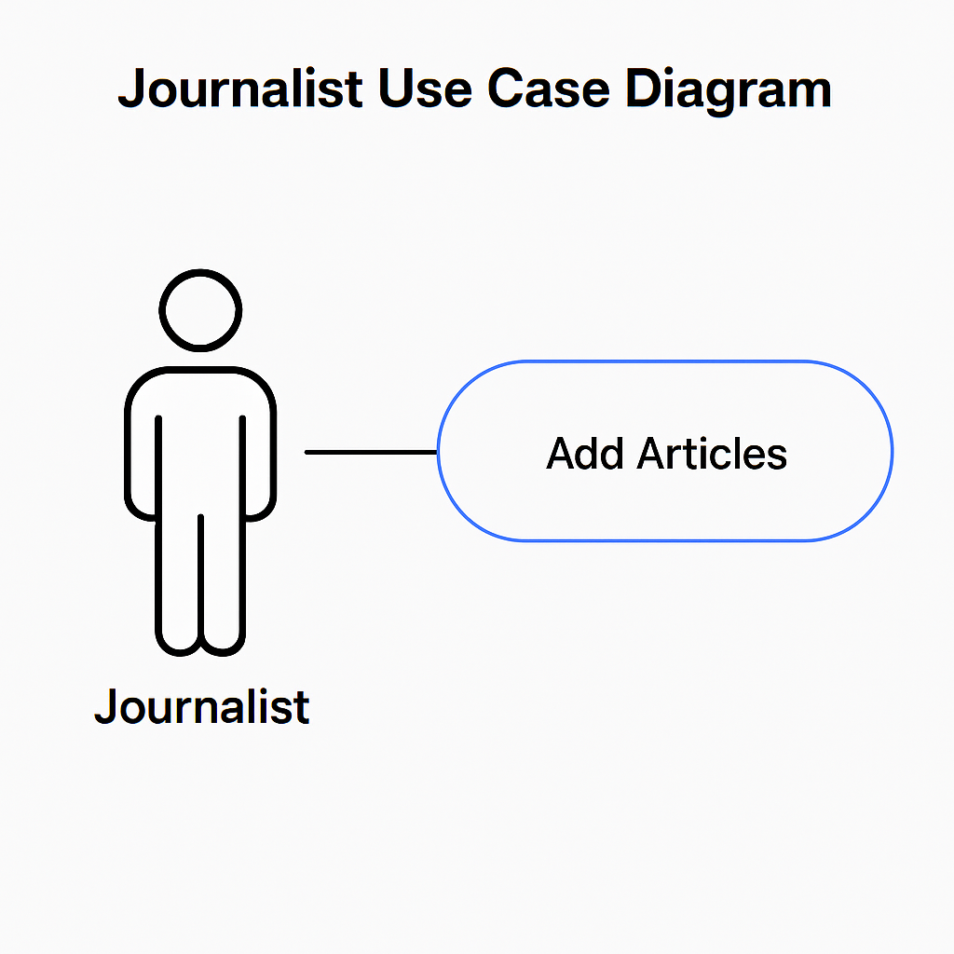

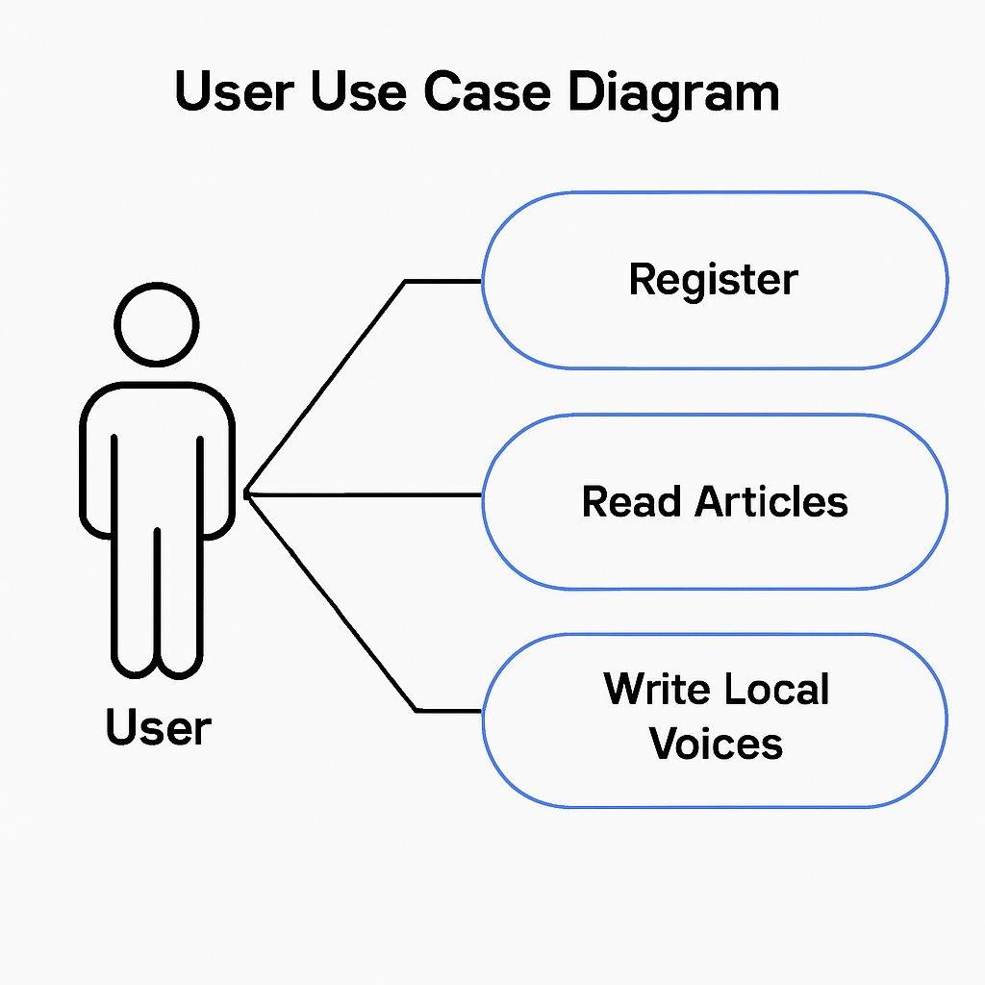 IV. General User side

4.2 NORMALIZATION:

Normalization is the process of organizing table data and relations of a relational database to reduce data redundancy and improve data integrity.

* Denormalized form-

Here, the data is stored in a single table, with repeating groups and redundancy. For example, in this table all the entities are crammed up in one table.

|  |  |  |  |  |  |  |  |
| --- | --- | --- | --- | --- | --- | --- | --- |
| USER ID | USERNAME | PASSWORD | ROLE | DISTRICT | ARTICLE ID | ARTICLE TITLE | ARTICLE CONTENT |
| 1 | admin | **** | Admin | Tapi | 101 | Economy Growth | Full content |
| 2 | Mod01 | *** | Moderator | Ahmedabad | 102 | Flood relief | Full content |
| 3 | User03 | *** | User | Jamnagar | 205 | Health camp in the city | Full content |

|  |  |  |  |  |  |
| --- | --- | --- | --- | --- | --- |
| IMAGE URL | CATEGORY | STATUS | IS_LOCAL_VOICE | SUBMIT-TIME | COMMENT-TEXT |
| Economy.jpg | Economy | Published | False | 2025-08-15  12:30 | NULL |
| Flood.png | Disaster | Published | False | 2025-07-25  15:00 | Should include helpline |
| Camp.jpg | Health | Pending | True | 2025-08-24  11:26 | Informative |

* First Normal Form (1NF):

Repeating data is removed, ensures atomic values and provides some structure. Redundancy is still there.

|  |  |  |  |  |
| --- | --- | --- | --- | --- |
| User ID | Username | Password | Role | District |
| 1 | admin123 | **** | Admin | Ahmedabad |
| 2 | mod01 | **** | Moderator | Surat |
| 3 | jour01 | **** | Journalist | Rajkot |
| 4 | user01 | **** | Reader | Vadodara |

Users table

Articles table

|  |  |  |  |  |
| --- | --- | --- | --- | --- |
| ArticleID | UserID | Title | Content | Status |
| 101 | 1 | Economy Growth | Full content... | Published |
| 102 | 2 | Flood Relief | Full content... | Pending |
| 103 | 3 | Sports Event | Full content... | Published |

LocalVoices table

|  |  |  |
| --- | --- | --- |
| VoiceID | UserID | Content |
| 301 | 1 | Road issue in XYZ area |
| 302 | 2 | Local market closed |
| 303 | 4 | Streetlight not working |

* Second Normal Form (2NF):

Removes partial redundancy, creates separate table for roles and districts.

Users table

|  |  |  |  |  |
| --- | --- | --- | --- | --- |
| USERID | USERNAME | PASSWORD | ROLE ID | DISTRICT ID |
| 1 | Admin123 | *** | 1 | 101 |
| 2 | Mod01 | *** | 2 | 102 |
| 3 | Jour01 | *** | 3 | 103 |
| 4 | User01 | *** | 4 | 104 |

|  |  |
| --- | --- |
| RoleID | RoleName |
| 1 | Admin |
| 2 | Moderator |
| 3 | Journalist |
| 4 | Reader |

Roles table

Districts table

|  |  |
| --- | --- |
| DistrictID | DistrictName |
| 101 | Ahmedabad |
| 102 | Surat |
| 103 | Rajkot |
| 104 | Jamnagar |

Articles table

|  |  |  |  |  |
| --- | --- | --- | --- | --- |
| ARTICLE ID | USER ID | TITLE | CONTENT | STATUS |
| 201 | 1 | Economic growth | Full content | Published |
| 202 | 2 | Flood relief | Full content | Pending |
| 203 | 3 | Sports event | Full content | Published |

Local Voices table

|  |  |  |
| --- | --- | --- |
| Local Voice ID | USER ID | CONTENT |
| 301 | 1 | Road issue in XYZ city |
| 302 | 2 | Local market closed |
| 303 | 4 | Public safety concerns |